| FULL LEGAL NAME | **LOCATION (COUNTRY)** | **EMAIL ADDRESS** | **MARK X FOR ANY NON-CONTRIBUTING MEMBER** |
| --- | --- | --- | --- |
| **DANIEL SIMWABA** | ZAMBIA | sulayman.m.f@gmail.com |  |
| **MBOUZOU FOMENA PALMAS** | CAMEROON | mbouzoufomena@gmail.com |  |
| **MUHAMMAD SULAYMAN** | NIGERIA | danielsimwaba@gmail.com |  |

| **Statement of integrity:** By typing the names of all group members in the text boxes below, you confirm that the assignment submitted is original work produced by the group (excluding any non-contributing members identified with an “X” above). | |
| --- | --- |
| **Team member 1** | **DANIEL SIMWABA** |
| **Team member 2** | **MBOUZOU FOMENA PALMAS** |
| **Team member 3** | **MUHAMMAD SULAYMAN** |

| Use the box below to explain any attempts to reach out to a non-contributing member. Type (N/A) if all members contributed.  **Note:** You may be required to provide proof of your outreach to non-contributing members upon request. |
| --- |
| N/A |

### Part 1: Assessing Models with Alternative Data

#### Q1. Data Understanding

1. **Data Collection (types of data are used in the paper to predict stock market movements,and how are technical indicators derived from this data)**

To replicate the methodology presented in "An Intelligent Approach for Predicting Stock Market Movements in Emerging Markets Using Optimized Technical Indicators and Neural Networks" by Sagaceta Mejia et al. (2023), we would follow these steps:

* + **Historical Price Data**: The paper used ETFs market data (structured data) obtained for example from Yahoo finance database, the attributes of the data used are Gather daily stock prices, which include open, high, low, close, and volume, for selected stocks in emerging markets over a significant period (e.g., 5–10 years) (Sagaceta et al. 4). Technical Indicators are derived from the data using Pandas Technical Analysis (**Pandas TA**) (Sagaceta et al. 4)
  + **Macroeconomic Data**: Collect relevant macroeconomic indicators such as GDP growth rates, inflation rates, interest rates, and exchange rates corresponding to the same timeframe.
  + **Market Sentiment Data**: Extract sentiment data from financial news articles, social media platforms, and analyst reports using natural language processing (NLP) techniques to gauge investor sentiment.

1. **Data Preprocessing (how technical indicators are derived from this data)** 
   * **Data Cleaning**: Address missing values through imputation methods or by removing incomplete records. Ensure data consistency and accuracy.
   * **Normalization**: Apply normalization techniques to scale numerical data, ensuring that features with larger ranges do not dominate the model training process.
   * **Feature Engineering**: Compute technical indicators such as Moving Averages (MA), Relative Strength Index (RSI), Bollinger Bands, and Moving Average Convergence Divergence (MACD) from the historical price data.

**Feature Selection Using LASSO Regression**

* + **LASSO Regression Application**: Implement Least Absolute Shrinkage and Selection Operator (LASSO) regression to identify and select the most significant features that influence stock price movements. This technique helps in reducing model complexity and preventing overfitting by penalizing less important features (Tibshirani, 1996).

**Neural Network Model Development**

* + **Architecture Design**: Design a neural network architecture tailored for time-series forecasting. A common choice is the Long Short-Term Memory (LSTM) network, which is effective in capturing temporal dependencies in sequential data (Hochreiter & Schmidhuber, 1997).
  + **Hyperparameter Tuning**: Optimize hyperparameters such as the number of layers, number of neurons per layer, learning rate, batch size, and activation functions using techniques like grid search or random search.

**Model Training and Validation**

* + **Data Splitting**: Divide the dataset into training, validation, and test sets, typically using an 80-10-10 split.
  + **Training Process**: Train the neural network model on the training set, utilizing the selected features and corresponding target variables.
  + **Validation**: Monitor the model's performance on the validation set to fine-tune hyperparameters and prevent overfitting.

**Model Evaluation**

* + **Performance Metrics**: Evaluate the model's predictive accuracy using metrics such as Mean Absolute Error (MAE), Root Mean Squared Error (RMSE), and directional accuracy (the percentage of correct up/down predictions).
  + **Cross-Validation**: Employ k-fold cross-validation to assess the model's robustness and generalizability across different subsets of the data.

**Implementation of Trading Strategy**

* + **Signal Generation**: Develop a trading strategy based on the model's predictions, generating buy or sell signals accordingly.
  + **Backtesting**: Test the trading strategy on historical data to evaluate its profitability and risk-adjusted returns.

**Analysis and Interpretation**

* + **Result Analysis**: Analyze the backtesting results to assess the strategy's performance, including metrics like cumulative returns, Sharpe ratio, and maximum drawdown.
  + **Sensitivity Analysis**: Conduct sensitivity analyses to understand the impact of different features and model parameters on the predictions.

3. **Importance of using such indicators in forecasting:**

Technical indicators play a crucial role in financial analysis, providing traders and investors with systematic, data-driven insights that enhance decision-making by filtering out market noise and identifying patterns indicative of future price movements. In modern financial markets, where numerous factors influence price dynamics, these indicators help in recognizing trends and momentum based on historical data, ultimately enriching analytical works with a diverse set of features that facilitate a nuanced exploration of market trends and enhance the depth of predictive analysis (Sagaceta et al. 4).

Technical indicators ensure that investment strategies remain repeatable and adaptable, minimizing reliance on intuition or speculative approaches. Moreover, integrating technical indicators with other analytical methods, such as fundamental or sentiment analysis, fosters a comprehensive investment strategy that balances qualitative and quantitative information. This integration enhances predictive accuracy and provides financial engineers with the tools to optimize portfolio performance while giving investors a competitive edge in the stock market.

#### Q2. Security Understanding

**a) Description of the three fund using ECH ETF and based on the ECH description on it’s page on Yahoo finance site:**

The iShares MSCI Chile ETF (ECH) is an exchange-traded fund created to track the performance of the MSCI Chile Investable Market Index 25/50, it provides investors with exposure to a broad range of Chilean equities. As at February 4, 2025, ECH is priced at $27.23, dropping by $0.10 (-0.37%) of the previous close. The intraday high reached $27.90, while the lowest price for the day was $26.82 ("iShares MSCI Chile ETF (ECH) Stock Price, News, Quote & History").

ECH has experienced a decline of approximately 6.76% over the past year. Historically, the fund reached an all-time high of $80.27, marking a significant decrease of about 68.06% from that peak ("ECH ETF Price, iShares MSCI Chile ETF"). In 2023, ECH started the year at $27.71 and ended at $25.64, reflecting a year-to-date decrease of 7.47% ("ECH ETF Price, iShares MSCI Chile ETF"). The fund's 52-week range has fluctuated between a low of $23.67 and a high of $29.57 ("iShares MSCI Chile ETF (ECH) Stock Price, News, Quote & History").

As of September 13, 2024, ECH had total net assets of $530.32 million, with a price-to-earnings (P/E) ratio of 4.42 and a yield of 3.27%. The fund also has an expense ratio of 0.59% ("iShares MSCI Chile ETF (ECH) Stock Price, News, Quote & History"). The ETF provides investors with targeted exposure to the Chilean equity market, including large-, mid-, and small-cap stocks. Its performance is influenced by various factors, such as commodity prices, political developments, and economic conditions in Chile.

The iShares MSCI Chile ETF (ECH) is known for its dividend yield, which is approximately 3.27% as of the latest report ("iShares MSCI Chile ETF (ECH) Stock Price, News, Quote & History"). This yield makes it an attractive option for an investor who want to invest in value stocks. The fund's performance is closely tied to Chile’s economic conditions, particularly the mining sector, as the country is one of the world’s largest copper producers. The fluctuation in commodity prices, especially copper, has a direct impact on ECH’s price movements.

ECH has a moderate expense ratio of 0.59%, which is standard for country-specific ETFs but slightly higher than broad-market ETFs ("iShares MSCI Chile ETF (ECH) Stock Price, News, Quote & History"). The fund provides a diversified approach to investing in Chile, encompassing companies across various sectors, including financials, utilities, and consumer goods. Over the years, ECH has experienced significant volatility, reflecting the broader economic cycles in emerging markets. Investors looking to add exposure to Chile’s market often consider ECH as a way to balance potential high returns with the risks associated with investing in a single-country ETF ("ECH ETF Price, iShares MSCI Chile ETF").

**b-1) Why do the authors decide to run a classification problem rather than a regression problem?**

The authors decided to run classification analysis so that the qualitative variable corresponds to the class label of the day. (Sagaceta et al. 3)

**b-2) 2 other examples of how they could have defined the classification variable**

Two other ways the classification variable can be defined are:

* Using 1 to represent large price increase, 0 to represent no change or negligible price change and -1 for large price drop.
* Using increase and decrease in volume traded instead of price change

### Q 3: Methodology Understanding

1. **Data Subcategories**: If section 2 is named “Data”, the subcategories of the section according to what was discussed in the section would be: 2.1 Data Collection, 2.2 Data cleaning, 2.3 Feature Engineering, and 2.4 Assignment of Class Label.
2. **Methodology Subcategories:** If section 3 is named “Methodology”, according to what is discussed in the section, the subcategories would be: 3.1 Methods of Feature Selection, 3.2 Neural Network Model, and 3.3 Cross-Validation Approach.
3. **Dividing descriptive statistics from models** using Pearson’s correlation and LASSO as case study:
4. Pearson’s Correlation: it is a descriptive statistics that measures the linear relationship between features (Sagaceta et al. 6).
5. LASSO: it’s a model that prevents overfitting from providing new information and hence modifying model’s parameter (Sagaceta et al. 6).

4. **Optimization of Technical Indicator:**

1. The author use feature selection to reduce indicator count per ETF (Sagaceta et al. 9).
2. The reduction improve the accuracy of model and computation cost (Sagaceta et al. 10).

### Q 4: Feature Understanding

1. The paper considers measurable stock indicators as feature (Sagaceta et al. 6).
2. Features are the input, Methods are the methods of processing and models are the prediction algorithm (sagaceta et al. 8).
3. The categories include: momentum, trends, volume, and volatility (sagaceta et al. 9).
4. The reasons for optimization include:
5. Improving computational cost and accuracy.
6. Improving generalization and reducing overfitting (sagaceta et al. 10).

**Q5: Optimization Understanding**

1. cross -validation is a model validation approach for determining how well a model”s result generalized to a new dataset(Sagaceta et al. 7).
2. In k-fold cross validation, the data is splitted into k parts, each part is used for training once and testing (k-1) times (Sagaceta et al. 7).
3. Jaccard distance is a metric that measures similarities of selected features across models.(Sagaceta et al. 8)
4. Comparing Jaccard distance with two other metrics:
5. Jaccard distance measures similarities of two sets(Sagaceta et al. 8).
6. Euclidean distance measures absolute difference between two values.
7. Cosine distance measures the angles between two feature vectors.

5. Optimal solution is the best model that balances accuracy and computational efficiency using the most predictive features (Sagaceta et al.

**Step 1: Financial Problem**

1. **What financial problem is the paper solving:** The paper is solving the problem of prediction of market trends of stocks in emerging markets (Sagaceta et al. 3 ).
2. **How does predicting stock market movement in emerging market differ from predicting in developed market and why is this distinction significant in the model design?:** predicting in emerging markets differs from predicting in developed markets because emerging markets have higher volatility than developed market and this distinction is significant in the model’s design because high volatility calls for a robust model than low volatility (Sagaceta et al. 3 - 4).

**Step 2: Application**

1. **Describe the main takeaway of the result:**
2. Neural networks are better than traditional statistical models for predicting market trends (Sagaceta et al. 7).
3. The MLP model successfully identifies non linear patterns (Sagaceta et al. 8).

2. **What specific features seem useful from the study?:** The useful features are volumes, trends, and volatility indicators (Sagaceta et al. 9).

**Step 3: Replication**

1. Pick on fund: ECH
2. Download it’s data: Yahoo Finance as data source
3. Pick an easier metric: Pearson’s correlation

**Part 2: Evaluating the use of Social Media data as Alternative Data in Finance,** AUser Guide for Exploiting Social Media Data to Aid Decision Making in Finance

**Q1. Sources of Data**

Social media data is a subcategory of behavioral alternative data in finance. It is from multiple platforms that engage users in discussions where they share opinions, discernments, experiences and perspectives. These platforms can be broadly classified into three categories:

* **Connection-Based Networks:** These networks assess sentiment trends with regards to a company’s performance, and with regards to financial markets. They include platforms like Twitter, Facebook, and LinkedIn. On these platforms, users establish connections and share public opinions.
* **Interest-Based Networks**: These networks zoom-in into finance-related discussions among investors, analysts, and industry insiders. They include platforms like Stocktwits and Seeking Alpha. Exploiting the conversations on these platforms, provide insights into investment risks, stock performance, and market sentiment.
* **Review-Based Networks**: These networks host reviews and ratings on products, services and corporate work environments generated by users. They include platforms like Yelp, Glassdoor, and Amazon. Exploiting reviews on these platforms are valuable in predicting employee satisfaction, consumer behavior, and company profitability.

**2. Types of Data**

The different types of social media data permit it to be classified under several categories with each having the capability of providing a unique insight. These data can be classified into 4 main types:

* **Text-Based Data**: This is made up of posts, comments, and tweets that express the opinions of on financial topics. These data types could be used to predict stock movements and investor sentiment using sentiment analysis.
* **Engagement Metrics:** These are metrics which indicate the level of public interest in a company, product, or financial topic. It Includes likes, shares, and comments. As an example, high engagement metrics may signal potential investment opportunities.
* **Influencer Data**: This is made up of influential figures whose posts on social media could impact market trends in a significant way. These influential figures can include members of government in strategic financial positions, financial analysts, corporate executives, and influential investors.
* **Visual and Multimedia Data:** This constitutes images, videos, and infographics shared across platforms. These data could be used to provide additional context to financial discussions.

**3. Quality of Data**

The quality of data obtained from social depends of several factors:

* **Accuracy and Authenticity**: This involves eliminating misinformation by careful validation of data as fake accounts and automated bots can distort market sentiment analysis.
* **Timeliness:** this includes making sure that the data obtained is updated in real-time.
* **Volume and Scalability**: This involves making use of the huge amount of social media data without being overwhelmed with the noise contained in the data.
* **Bias and Representativeness:** This deals with taking into account the biases present on social media when exploiting.

**4. Ethical Issues**

The use of social media data in to make financial decisions requires the highlighting of four major ethical considerations:

* **Privacy Concerns:** The analysis of individual user behavior for financial decisions unveils legal and data privacy issues although social media is considered public.
* **Market Manipulation Risks**: stock prices could be intentionally manipulated by some entities that wish to propagate financial misinformation for personal gains.
* **Algorithmic Bias:** The data used in training machine learning models used in social media can create inherent biases providing misleading financial predictions.
* **Regulatory Compliance:** The use of social media by financial entities is also regulated by a set of rules that ensure ethical data practices, transparency and consumer protection.

**5) Python code to import and structure social media data (the case of tweets) into useful data structures: (See for .ipynb file for code and pdf file execution output)**

We begin by reading data from a CSV file containing tweet data, parsing date fields to ensure they are in a consistent datetime format, and performing data cleaning tasks such as URL removal and duplicate elimination.

The code then structures the cleaned data by aggregating it into daily metrics—counting the number of posts per day and calculating average likes and retweets—thus converting raw social media content into organized, analysis-ready data structures suitable for further financial projections or predictive modeling.

**6) Exploratory data analysis of sample data (See for .ipynb file for code and pdf file execution output):**

The code elaborates to this effect builds upon the initial data processing steps by using some of visual EDA components to offer further insights into the sample tweet data.

After cleaning and aggregating the raw data, the code uses matplotlib and seaborn to create visualizations: histograms and boxplots show the distribution and potential outliers in like counts, while scatter plots show the relationship between likes and retweets across different users.

1. Additionally,**Sources of Climate Data**

Sensor-based data is derived from various physical sensors deployed across different platforms:

* **Satellite Imagery**: Collected by satellites orbiting the Earth, providing high-resolution images used for monitoring environmental changes, urban development, and agricultural patterns.
* **Geolocation Data**: Obtained from GPS-enabled devices, capturing movement patterns of individuals or assets, useful in logistics, retail analysis, and traffic management.
* **Environmental Sensors**: Devices measuring parameters like temperature, humidity, air quality, and pollution levels, aiding in climate studies and public health assessments.

**2. Types of Climate Data**

The data collected from these sensors can be categorized as follows:

* **Imagery Data**: Visual data from satellites or drones, often requiring processing to extract meaningful information.
* **Positional Data**: Coordinates and movement tracks from GPS devices, providing insights into location-based activities.
* **Environmental Metrics**: Quantitative measurements from environmental sensors, offering data on various ecological parameters.

**3. Quality of Data**

The quality of sensor-based data depends on several factors:

* **Resolution**: Higher resolution provides more detailed information but may come with increased data volume.
* **Accuracy**: The precision of the data in representing real-world conditions.
* **Timeliness**: The frequency and recency of data collection, crucial for time-sensitive analyses.
* **Completeness**: The extent to which the data covers the area or parameters of interest without gaps.

**4. Ethical Issues** Geo data

Utilizing sensor-based data raises several ethical considerations:

* **Privacy Concerns**: Geolocation data can reveal personal movement patterns, leading to potential privacy infringements.
* **Data Ownership**: Determining who owns the data collected by sensors, especially when deployed in public spaces.
* **Surveillance**: The use of imagery and geolocation data can lead to unauthorized monitoring of individuals or groups.

## Q7) Short literature search that links to papers citing research on the use of Climate data as an alternative source of data for finance, Case study: Zambia

***Applying Climate Data to Real World Situations - Impact of Climate Change on Economy, Business, and Financial Activities: Use Case of Zambia***

Impact of Climate Change on Zambia's Economy, Business, and Financial Activities Climate change poses significant challenges to Zambia's socio-economic development, affecting various sectors, business operations, and corporate financial activities. The country's heavy dependence on climate-sensitive industries, such as agriculture and energy, makes it particularly vulnerable to extreme weather events. In recent years, Zambia has witnessed increasing droughts, unpredictable rainfall, and temperature fluctuations, all of which have far-reaching consequences on its economy, financial stability, and business sustainability.

**Economic Impact of Climate Change in Zambia**

Zambia's economy is highly susceptible to climate variability, with key sectors such as agriculture, infrastructure, and energy being critically affected. According to Zambia’s ‘National Policy on Climate Change’, prolonged dry spells and erratic rainfall patterns are already disrupting food production and water availability. The impact of these conditions is evident in declining agricultural yields, rising food prices, and an overall decrease in GDP growth. The 2024 drought, one of the worst in recent decades, caused severe food shortages and led the government to declare a national emergency.

Additionally, the energy sector, which relies heavily on hydropower, has been significantly affected by declining water levels in major reservoirs. The drought affecting Lake Kariba, the world’s largest man-made lake, has led to severe electricity shortages. Only one of its six turbines is operational , reducing Zambia’s power output to less than 10% of its installed capacity. This has resulted in frequent power outages, negatively impacting industrial production, business operations, and household livelihoods.

**Business and Corporate Financial Implications of Climate Change**

The financial sector in Zambia is also exposed to climate risks. A stress test on five African banking systems, including Zambia’s, revealed potential systemic risks posed by environmental degradation. Key industries, such as agriculture and forestry, which drive a significant portion of economic activity, are under immense financial strain due to declining productivity and rising input costs. Nature-related losses, such as deforestation and pollinator decline, are projected to cause substantial reductions in profit margins for businesses that depend on ecosystem services.

Moreover, the ongoing energy crisis has forced businesses to rely on expensive alternative power sources, such as diesel generators and solar energy, increasing operational costs. Businesses in mining and manufacturing, two of Zambia’s largest foreign exchange earners, reported reduced productivity due to erratic power supply, further affecting foreign investment and overall financial stability.(World Bank,2024)

**Analysis of Climate Change Through Google Earth Engine Imagery.**

To better understand the impact of climate change on Zambia’s environmental conditions, two satellite imagery datasets from ‘Google Earth Engine’ were analyzed, focusing on vegetation health and rainfall distribution over two critical periods.

***Zambia’s Dry Period Analysis (September 1, 2024 – November 1, 2024)***

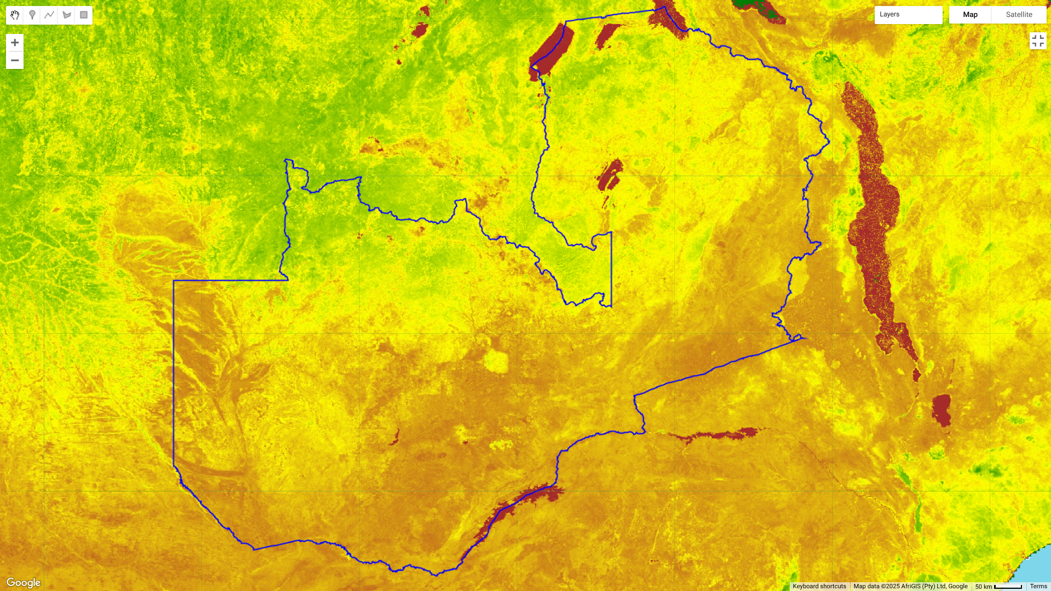

Source : https://code.earthengine.google.com/a31bb30ecfe4f2d206917911231c6b81

The satellite imagery for **September to November 2024** reveals widespread **yellow coloration**, indicating low vegetation density and reduced moisture content The southern and western parts of Zambia appear particularly dry, which corresponds with seasonal drought conditions. Large patches of **red areas** are visible in the Eastern and Southern provinces, signifying high levels of vegetation stress or deforestation-related land degradation. This period aligns with Zambia’s traditional dry season, where rainfall levels are minimal, and water resources are heavily strained.

The Zambezi River and surrounding floodplains appear significantly smaller, suggesting lower water availability, which could negatively impact agriculture, livestock rearing, and hydroelectric generation.

***Zambia’s Wet Period Analysis (December 5, 2024 – February 3, 2025)***

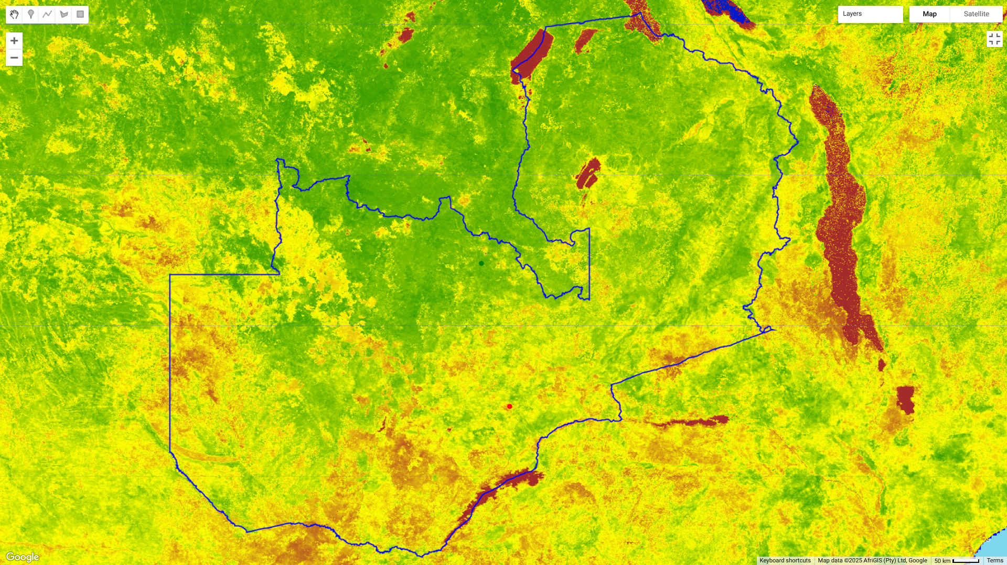

Source : https://code.earthengine.google.com/?scriptPath=users%2Fdanielsimwaba%2FZambia%3ASEPT%20to%20NOV%20DROUGHT

In contrast, the **December to February 2025** satellite imagery shows an **increase in green vegetation**, particularly in northern and central Zambia, reflecting the onset of the rainy season and improved moisture availability. The southern regions remain relatively dry, but there are visible signs of gradual vegetation recovery, particularly along major river basins and cultivated farmlands.

Notably, the deep red stress areas observed in the earlier period have reduced, indicating some recovery from previous drought conditions. However, persistent dry zones in the southwestern parts of Zambia suggest that certain areas may still be facing long-term water shortages, requiring immediate intervention strategies.

**Key Comparative Insights Between the Two Periods**

The capture of September–November to December–February highlights the stark contrast between Zambia’s dry and wet seasons. The rainfall increase in December–February has led to improved vegetation health in many regions, but certain drought-prone areas remain vulnerable. The southern provinces, in particular, show slow recovery, which could indicate more prolonged dry spells or inefficient water retention.

From an economic and business standpoint, this data reinforces the need for climate adaptation policies, particularly in irrigation expansion, improved water storage systems, and drought-resistant crop farming techniques.

**Government Initiatives and Climate Adaptation Strategies**

Recognizing the growing climate risks, the Zambian government has taken steps to enhance climate resilience. The National Adaptation Plan (NAP 2023) aims to integrate climate adaptation measures into national development planning. Additionally, the Green Growth Strategy (2024-2030) seeks to promote sustainable land use and conservation by linking financial incentives to environmental protection efforts.

The government is also exploring carbon trading and climate finance mechanisms as ways to fund climate mitigation projects. Recent reports with organizations such as the World Bank indicate that Zambia has entered discussions with international financial institutions to secure funding for climate-resilient infrastructure and renewable energy projects such as the NEAT Project supported by World Bank.

**Drought and Small Businesses**

The intricate economic principle that one individual's expenditure constitutes another's income becomes particularly evident during periods of drought. Droughts severely diminish agricultural yields, leading to decreased income for farmers. This reduction in spending power affects businesses that rely on farmers as customers, such as suppliers of farming equipment and local retail shops. Consequently, these businesses experience a decline in sales and revenue. The cumulative effect of reduced revenues and increased costs leads to significant liquidity challenges for small and medium-sized enterprises (SMEs). With diminished cash flow, these businesses struggle to meet financial obligations, such as paying suppliers, employees, and servicing debts. Prolonged liquidity issues can result in insolvency, business closures, and increased unemployment, further weakening the economic fabric of communities.

Here's a table of literature summarizing the economic, business, and financial impacts in Zambia around the periods of **September–November 2024 and December 2024–February 2025:**

| **Impact Area** | **September–November 2024** | **December 2024–February 2025** |
| --- | --- | --- |
| **Agriculture** | - **Drought Effects**: Severe drought led to a **15% reduction in crop yields**, causing significant food shortages.  [futures.issafrica.org](http://futures.issafrica.org)  - **Food Security**: The decline in agricultural output heightened food insecurity across the nation. | - **Recovery Efforts**: Initiatives like the **Zambia National Service's winter maize project** aimed to mitigate food shortages by cultivating maize during the off-season.  - **Continued Challenges**: Despite efforts, the agricultural sector faced ongoing challenges due to residual drought effects. |
| **Energy** | - **Hydropower Shortfall**: The drought caused **Lake Kariba's water levels to drop**, reducing hydropower capacity to less than 10% and leading to **up to 21-hour daily power cuts**.  [theguardian.com](http://theguardian.com)  - **Economic Impact**: Power shortages severely affected businesses and households, exacerbating economic difficulties. | - **Load Shedding**: Persistent low water levels necessitated continued **load shedding**, with daily power outages.  - **Diversification Efforts**: The government promoted alternative energy sources, including solar power, to reduce reliance on hydropower. |
| **Inflation** | - **Rising Inflation**: Annual inflation increased to **15.7% in October 2024**, driven by higher food and energy prices.  [boz.zm](http://boz.zm) | - **Continued Inflationary Pressure**: Inflation further climbed to **16.7% in December 2024**, marking the highest rate since November 2021.  [tradingeconomics.com](http://tradingeconomics.com) |
| **Economic Growth** | - **GDP Slowdown**: Real GDP growth slowed to **1.9% year-on-year in the first half of 2024**, reflecting contractions in agriculture and energy sectors.  [worldbank.org](http://worldbank.org) | - **Growth Projections**: The economy was projected to grow by **2.3% in 2024**, with expectations of a rebound to **6.6% in 2025** driven by improvements in mining and agriculture.  [vcda.afdb.org](http://vcda.afdb.org) |
| **Business and Financial Activity** | - **Operational Challenges**: Businesses faced increased operational costs due to reliance on alternative power sources amid electricity shortages.  [apnews.com](http://apnews.com)  - **Financial Strain**: Key industries, including agriculture and manufacturing, experienced financial strain due to reduced productivity and rising costs. | - **Investment Prospects**: Despite challenges, foreign direct investment (FDI) was projected to reach **3.9% of GDP in 2024**, with significant investments in mining and renewable energy sectors.  [ifc.org](http://ifc.org)  - **Debt Restructuring**: The government engaged in debt restructuring negotiations to improve fiscal stability and attract investment.  [reuters.com](http://reuters.com) |

This table highlights the multifaceted impacts of climate-induced challenges on Zambia's economy, business, and financial activities.

**Conclusion and Future Outlook**

The evidence from satellite imagery and economic data clearly illustrates the profound impact of climate change on Zambia’s economy, business operations, and financial stability. Key industries, such as agriculture, energy, and banking, remain highly vulnerable to climate shocks, necessitating urgent adaptation measures.The imagery analysis underscores the seasonal fluctuations in vegetation health, reinforcing the importance of early warning systems, improved water management, and diversified energy sources. Moving forward, Zambia must continue investing in climate-smart policies, while corporations and businesses need to integrate environmental risk assessments into their financial strategies to ensure long-term economic stability.

## References

1. Associated Press. (2024, October 10). Drought is parching the world's largest man-made lake, stripping Zambia of its electricity. Retrieved from https://apnews.com/article/6e3e746566b0831491e72de380f4079d
2. Ministry of Green Economy and Environment. (2016). National Policy on Climate Change. Retrieved from PMRCZAMBIA.COM
3. Ministry of Green Economy and Environment. (2023). Sustainable energy investment opportunities in Zambia. Retrieved from https://www.mgee.gov.zm/wp-content/uploads/2024/12/Sustainable-Energy-Investment-Opportunities-in-Zambia.pdf
4. Ministry of Green Economy and Environment. (2024). National Green Growth Strategy 2024-2030. Retrieved from MGEE.GOV.ZM
5. Parliament of Zambia. (2024). Report on carbon markets and trading in Zambia. Retrieved from https://www.parliament.gov.zm/sites/default/files/documents/committee_reports/Report%20of%20the%20Committee%20on%20Agriculture%2C%20Lands%20and%20Natural%20Resources%20on%20Carbon%20Markets%20and%20Trading%20in%20Zambia.pdf
6. Reuters. (2024, July 15). African bank stress test flags systemic risks posed by nature loss. Retrieved from https://www.reuters.com/business/finance/african-bank-stress-test-flags-systemic-risks-posed-by-nature-loss-2024-07-15/
7. Sagaceta Mejía, A. R., Sánchez-Gutiérrez, M. E., & Fresán-Figueroa, J. A. (2024). An intelligent approach for predicting stock market movements in emerging markets using optimized technical indicators and neural networks. *Economics*, 18(1), 1-14. doi:10.1515/econ-2022-0073
8. Sun, Y., Liu, L., Xu, Y., Zeng, X., Shi, Y., Hu, H., Jiang, J., & Abraham, A. (Year). Alternative data in finance and business: Emerging applications and theory analysis (Review). *Journal Name*.
9. World Bank. (2024, March 15). World Bank boosts support for the financial sustainability, reliability, and resilience of Zambia’s electricity sector. Retrieved from https://www.worldbank.org/en/news/press-release/2024/03/15/world-bank-boosts-support-for-the-financial-sustainability-reliability-and-resilience-of-afe-zambias-electricity-sector
10. Yahoo Finance. (2025). ECH. Retrieved from https://finance.yahoo.com/quote/ECH/. Accessed 4 Feb. 2025.